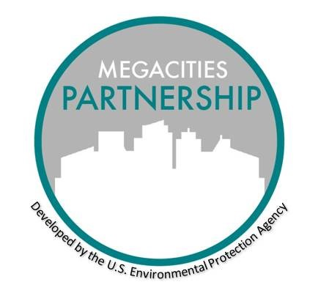

MEGACITIES PARTNERSHIP

Capacity Building Workshops

May 2021

Priority Component of the Megacity Framework

Achieving clean air is not solely a question of implementing known mitigation measures. Successful air quality management depends in large part on building local expertise to analyze and deliver locally relevant air pollution solutions. This makes a focus on capacity building a priority activity under the Megacity Framework.

Capacity Building Activities

This template offers a range of capacity building programs to be adapted to local needs. During the Megacity Pilot programs, capacity building was accomplished through a series of two or three in-person workshops interspersed with topical virtual webinars. Often this can begin with an introductory workshop in the inception phase of the project. As with all Megacity Framework components, successful capacity building involves advance planning and close coordination with local partners. This template offers potential topics of interest, with associated examples, which can help organize the thinking and planning for capacity building activities. Note that it is common to revisit topics multiple times to best familiarize relevant staff about these complex issues.

Audiences

One of the biggest challenges facing those who provide training and capacity building is getting the right people in the room. For this reason, a critical aspect of planning is ensuring there is clear understanding of the capacity building content, and who is the intended audience for different kinds of content. An important lesson learned in the Megacity Partnership pilot programs was that it is extremely important to focus most of the capacity building and training efforts on those staff who will ultimately be tasked with conducting the work. Recognizing there may also be interest on the part of middle and high-level managers across multiple government and academic institutions to attend, consideration may be given to organizing workshops such that different sessions can be targeted toward different audiences.

Topics

Information gathered during scoping and inception missions can provide a foundation for understanding capacity building needs, and topics should align with Megacity Partnership specific objectives. In addition, when planning for multiple capacity building workshops, consideration should be given to doing so with a scaffolding approach that builds knowledge over time and also offers some redundancy in material covered. Common topics of interest include:

* Air Quality Management Basics
  + Building blocks of an air quality management program
  + How other countries successfully have made progress toward clean air
* Key Components of the Air Quality Management Cycle
  + Ambient Monitoring
  + Emission Inventory
  + Source Apportionment
  + Data Management and Interpretation
  + Setting Ambient and Emission Standards
  + Program Implementation
  + Air Quality Management Plan Development
  + Cost-effective Controls and Mitigation Strategies
  + Communication Planning
  + Public Involvement
* Advanced Aspects of Air Quality Management
  + Health impact analysis of AQMP scenarios
  + Valuation of baseline health assessment and scenarios
  + Lab analysis techniques (e.g. chemical speciation)

Workshop Details

Objectives

*Fill in main objectives of capacity building efforts in specific megacity. Objectives could include:*

* For an introductory or inception workshop:
  + Build capacity to apply existing analytical tools, approaches and techniques to the challenge of air pollution mitigation strategies at a national scale;
  + Develop capacity, apply tools and analysis, and motivate action to address air pollution in the Megacity area; and
  + Spark interest and action among regional air quality experts to develop a systematic program of Air Quality Management Planning (AQMP).
* For a second workshop:
  + Basics of an air quality management plan, including target mitigation strategies;
  + Development of a baseline burden assessment using locally available data;
  + Refine and finalize baseline health impact analysis, develop policy scenarios considered by AQMP;
  + Basic laboratory analysis and assessment techniques, with demonstrations

Outputs

Outputs will vary depending on the objectives of the workshops but should be identified in advance to ensure alignment with overall Megacity Partnership goals. Example workshop outputs include:

* Begin to incorporate health benefits assessment into AQMP.
* Continue improving technical abilities.
* Add complexity to benefits analyses, potentially including cause-specific health morbidity and mortality endpoints and economic valuation.
* AQMP Drafts